**APPLE MAPS**

**Problem Identification:**

Apple Maps has made great progress with enhancing the functionality and usability over the years of its application; it stays up-to-date on critically evaluating the obstacles and persistent problems that emerge within its app.  By acknowledging these issues, we might find ways for enhancements and innovations that will furthermore improve the usage of Apple Maps and retain user participation for the application.

1. What are the symptoms for maps? (Low market Share)
2. Identify a Hypothesis  (What guess can we make on the causes of those symptoms?)
   1. Is it a pricing issue?
   2. Positioning issue?
   3. Product Issue?
   4. Promotion Issue?
   5. Post-purchase? (customer satisfaction)
3. Translate the Marketing research problem into marketing research objectives (what informations we need to collect to test our Hypothesis)

Problems:- When we search for a location, Google contextualizes effectively by informing us when it will open next. Apple will provide you their complete business hours, but they are hidden behind some scrolling and clicking. Additionally, Google will notify you prior to that the place is closed if you navigate to it later.

**Symptom:** Low market share

**Potential MKTG Cause:** Poor value proposition/ brand awareness/ Biased customer perception

What Informations do we need to collect to verify that Hypothesis?

**Conduct secondary research covering background information on the business you have selected. Describe the company, product, pricing, and several competitors. What makes this company different from its competitors?**

**(Product)** Apple Maps is a commonly used navigation app that was put together by Apple in 2012. They offer users a variety of features to aid in locating a destination for travel.

**(Pricing)** The service has been and is still free for all apple users and can be used as long as the user has an apple device in their possession. **(Competitors)** This market is quite  competitive, there are many other businesses, small to large, that offer such services, including Google Maps, Waze, HERE, WeGo, MapQuest, and many others. Google Maps currently dominates the mobile maps market with an 80% market share, and Apple Maps is right behind them with 10-12% of the market share. **(Value Proposition)** What makes Apple Maps unique is their cleaner interface, which is appealing to the eyes of users. Another important difference with the competition is that Apple Maps makes an emphasis on data privacy, unless the user opted-in to data sharing. Apple maps give users options to delete their data, unlike Google Maps where they advertise suggested locations to visit based on historical search data. Even though apple maps had a rough start (Tim Cook, Apple CEO even made a public apology for bad user experience), it made lots of updates and significant investments over time, and their product now matches google maps in terms of features and value.

**Identify the management/business problem or opportunity that you feel needs to be managed. Put yourself into the "shoes of the decision-maker" and identify symptoms. Do secondary research and supply charts and graphs supporting the symptoms you have identified.**

As briefly introduced above, apple maps is currently facing some issues, they are struggling to gain **market share** over google maps, and the user base is as well lower than this main competitor. According to the chart below, in 2019, apple maps was only the 3rd most popular mapping service available with a reach of 12%. Google maps also has 154.4 million active users each month whereas apple maps has only 23.3 million.

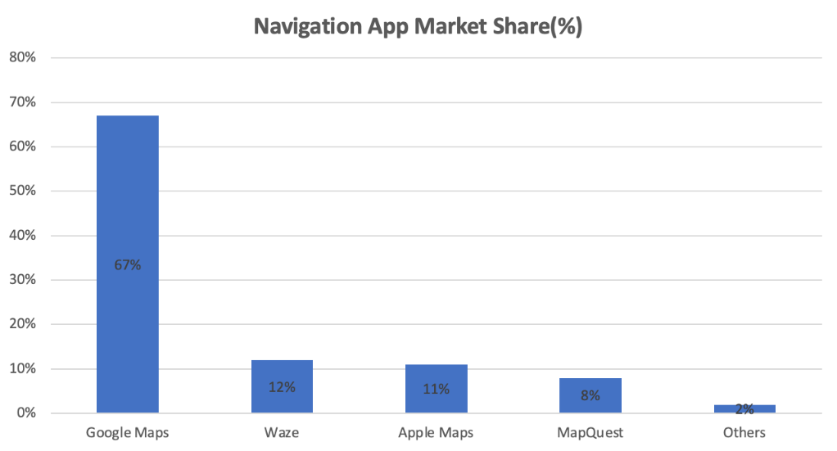Source:The Manifest,RBC Capital Markets

They also seem to have a **popularity (Reach)** issue as in 2018, 72% of consumers stated they prefer google maps while only 11% had a favorable opinion towards apple maps

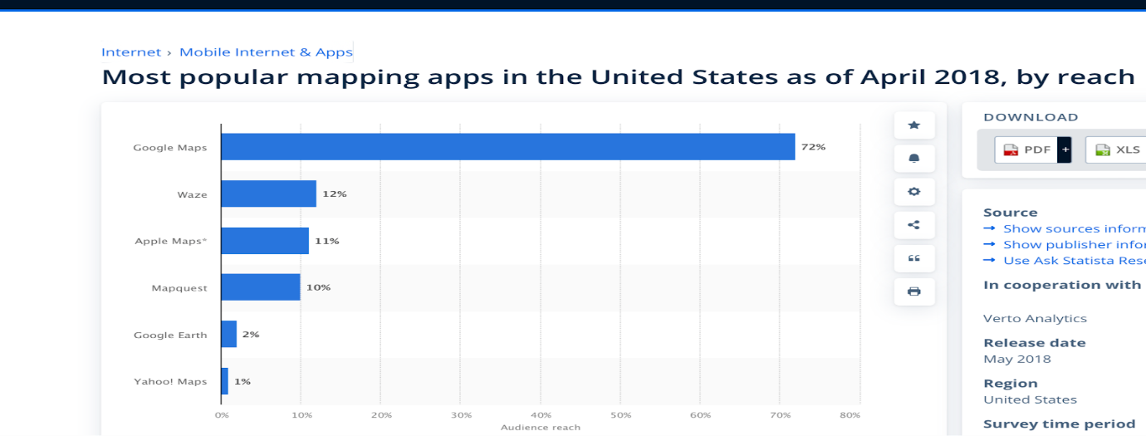*Most Popular Mapping apps in the US (April 2018) by reach (Source: Statista)*

Apple managers are probably wondering why that is the case, so let’s see how apple maps was doing feature wise, and popular wise to better understand where the problem they face today  is coming from.

**Next, translate the management problem into a marketing problem/issue or hypothesis. Identify causes. Use a marketing framework and select a marketing problem that you believe needs to be researched in terms of managing/fixing the business problem. For example, possible options may be either a customer satisfaction issue or a product development issue. Discuss the marketing management problem and discuss why the marketing research information you will be collecting will help solve the problem. Please use textbook references in support of your marketing problem.**

(1) One of the principal reasons why apple map lags behind, is that google maps has a greater database of geographic and crowd sourced data and is technically more **reliable** when calculating commutes and travel plans. As you can see in the Image below, google maps shows more routes and small paths compared to apple maps. Additionally, Google will notify you prior to that the place is closed if you navigate to it later while Apple Maps did not in the past.

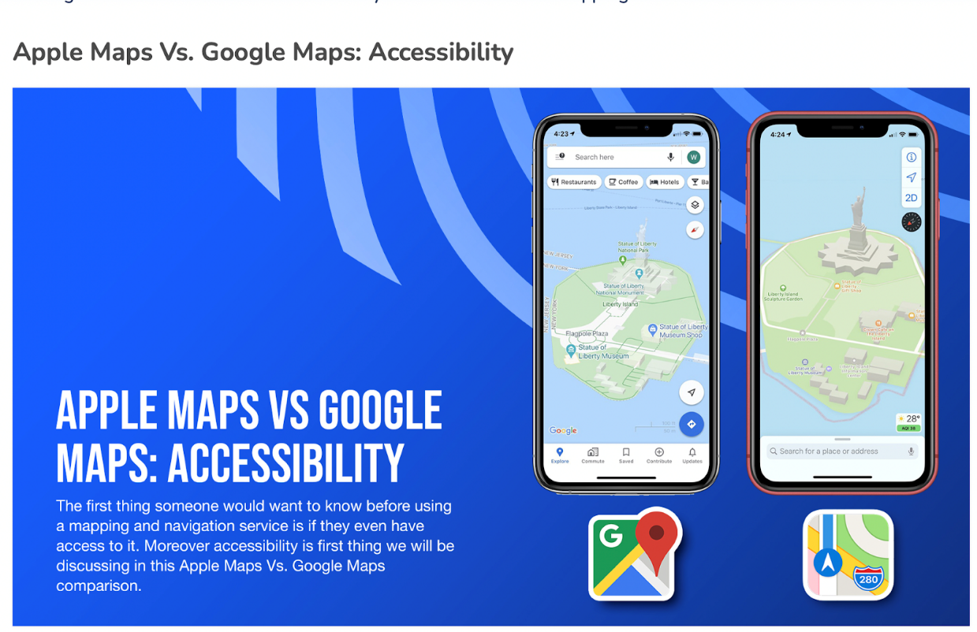 (2022 - [source](https://agilestorelocator.com/blog/apple-maps-vs-google-maps-comparison-guide-2022/))

(2) Moreover, the first couple versions of apple maps around 2012 had a very poor **interface/ usability**  while google maps user interface was much more user friendly. When we search for a location, Google contextualizes effectively by informing us when it will open but with regards to Apple maps, it will provide you their complete business hours, but that information is harder to access as it is hidden behind some scrolling and clicking. In recent years, Apple has made a lot of investment to make their interface better and more reliable, but their market share doesn’t seem to evolve according to the investments made. Because of this, we believe that google maps established a very strong reputation in this field compared to apple maps, and that generated a loyal customer base still present today. To “steal” customers from google maps, apple now has to run the extra mile; they have to convince users to switch back to maps.

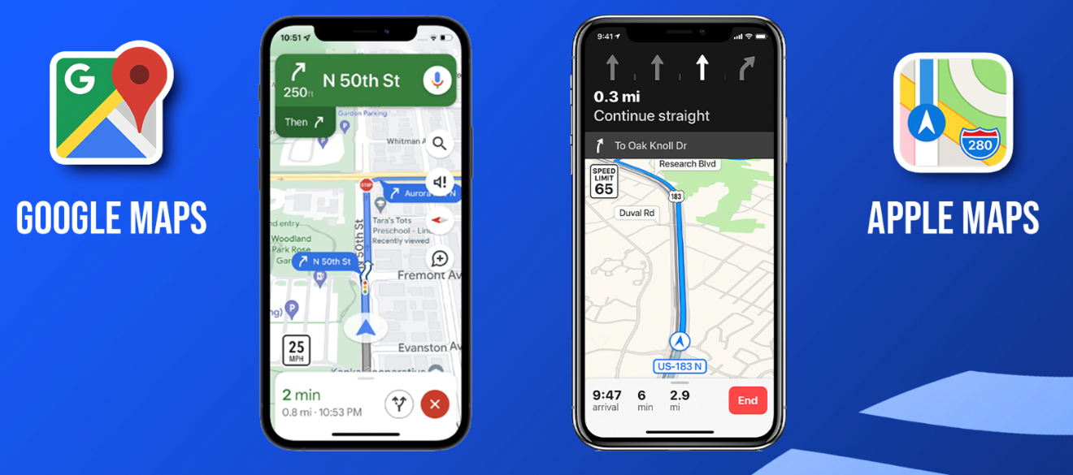

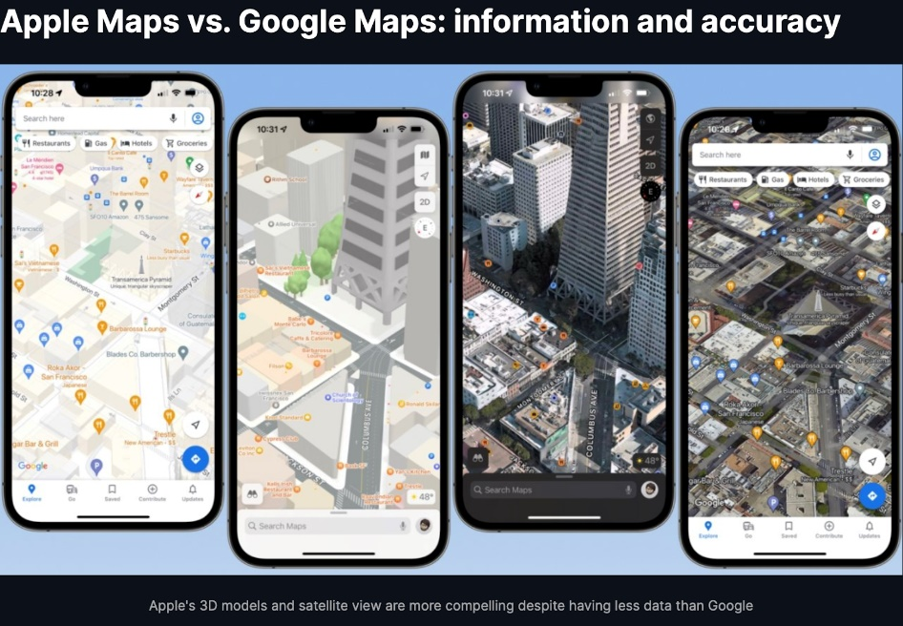(2022 - [source](https://agilestorelocator.com/blog/apple-maps-vs-google-maps-comparison-guide-2022/))

(3) Another problem that Apple maps is facing is related to **availability**. Indeed, it is only available to Apple Product users, while competitors like google maps are available on any device.

Those reasons can in part explain why apple maps has such a low market share and low user base compared to google maps, we could therefore question the value of apple maps vs google maps in terms of product quality. However,  as mentioned in the introduction; in recent years, Apple has invested a lot of money for their map app, and in terms of value they match up the service offered by google maps, but they haven't seen their market share evolve significantly since then, so if it is not product quality, what could explain the struggle to gain market share?

As briefly mentioned in the second point, our **hypothesis** is that **because apple maps had such a bad start, with a service of poor quality as shown above, consumers have built a loyalty towards google maps, and users are now hardly switching to apple maps.** Moreover, google maps was introduced in 2005 while apple maps in 2012, so long-therm users might not even consider making a switch. Additionally, improvements in features, accuracy and options for offline maps makes Apple a great choice for users.

Availability Hypothesis:

* **why the marketing research information you will be collecting will help solve the problem.**

By researching information from customers, we can expect to have a better understanding of how consumers perceive apple maps vs google maps product features, and identify if there is indeed a brand loyalty towards Google maps. If those results validate our hypothesis, then Apple could consider running massive advertising campaigns to change consumer awareness towards their product.

**Translate the marketing problem into a list of marketing research objectives. These objectives must be specific, measurable, and actionable (use bullets when describing your research objectives) and related to the marketing problem you will be investigating. For instance, think of what you will want to know and ask consumers to describe and diagnosis solutions to a customer satisfaction or product development marketing problem. What sources did you use?**

* Is apple low usage linked to consumers preferring google over apple? Or is it an availability Issue?
  + Compare apple map user and google map user preferences in terms of features
  + Compare apple map user and google map user in terms of loyalty
  + Open ended survey reply: Why do consumers prefer one over the other?
  + Divide mobile device user for result interpretation (Android, apple, other device types)

* How is Apple maps perceived? What are consumers' expectations in terms of features? What would they like to see that’s new/innovative?
  + What features are essential to consumers?
  + Propose a set of features in a question and see which are more important to consumers?
  + Open ended survey reply: What innovative ideas can be included on the Apple maps ?

* The most common issues on apple maps? How does apple address for it?
* What actions can apple take to reach most of the users (Mac and Non mac users)?

* Is maps failing because of a usability issue? Or because they fail to convince consumers it is worth using? -> Is it a customer perception problem or rather the service itself?

**Sources:**

* <https://www.forbes.com/sites/petercohan/2012/09/27/apple-maps-six-most-epic-fails/?sh=5ef80747df9d>
* <https://www.zdnet.com/article/apple-maps-vs-google-maps/>
* <https://www.wsj.com/articles/apple-maps-app-popularity-iphone-8e52aec1>
* <https://groups.google.com/>
* <https://appleinsider.com/articles/22/05/13/compared-apple-maps-versus-google-maps-in-2022>
* <https://techpp.com/2022/12/09/how-to-use-apple-maps-on-android-and-windows/>
* <https://www.theverge.com/23323550/apple-maps-10-year-anniversary-iphone-google>
* <https://agilestorelocator.com/blog/apple-maps-vs-google-maps-comparison-guide-2022/>